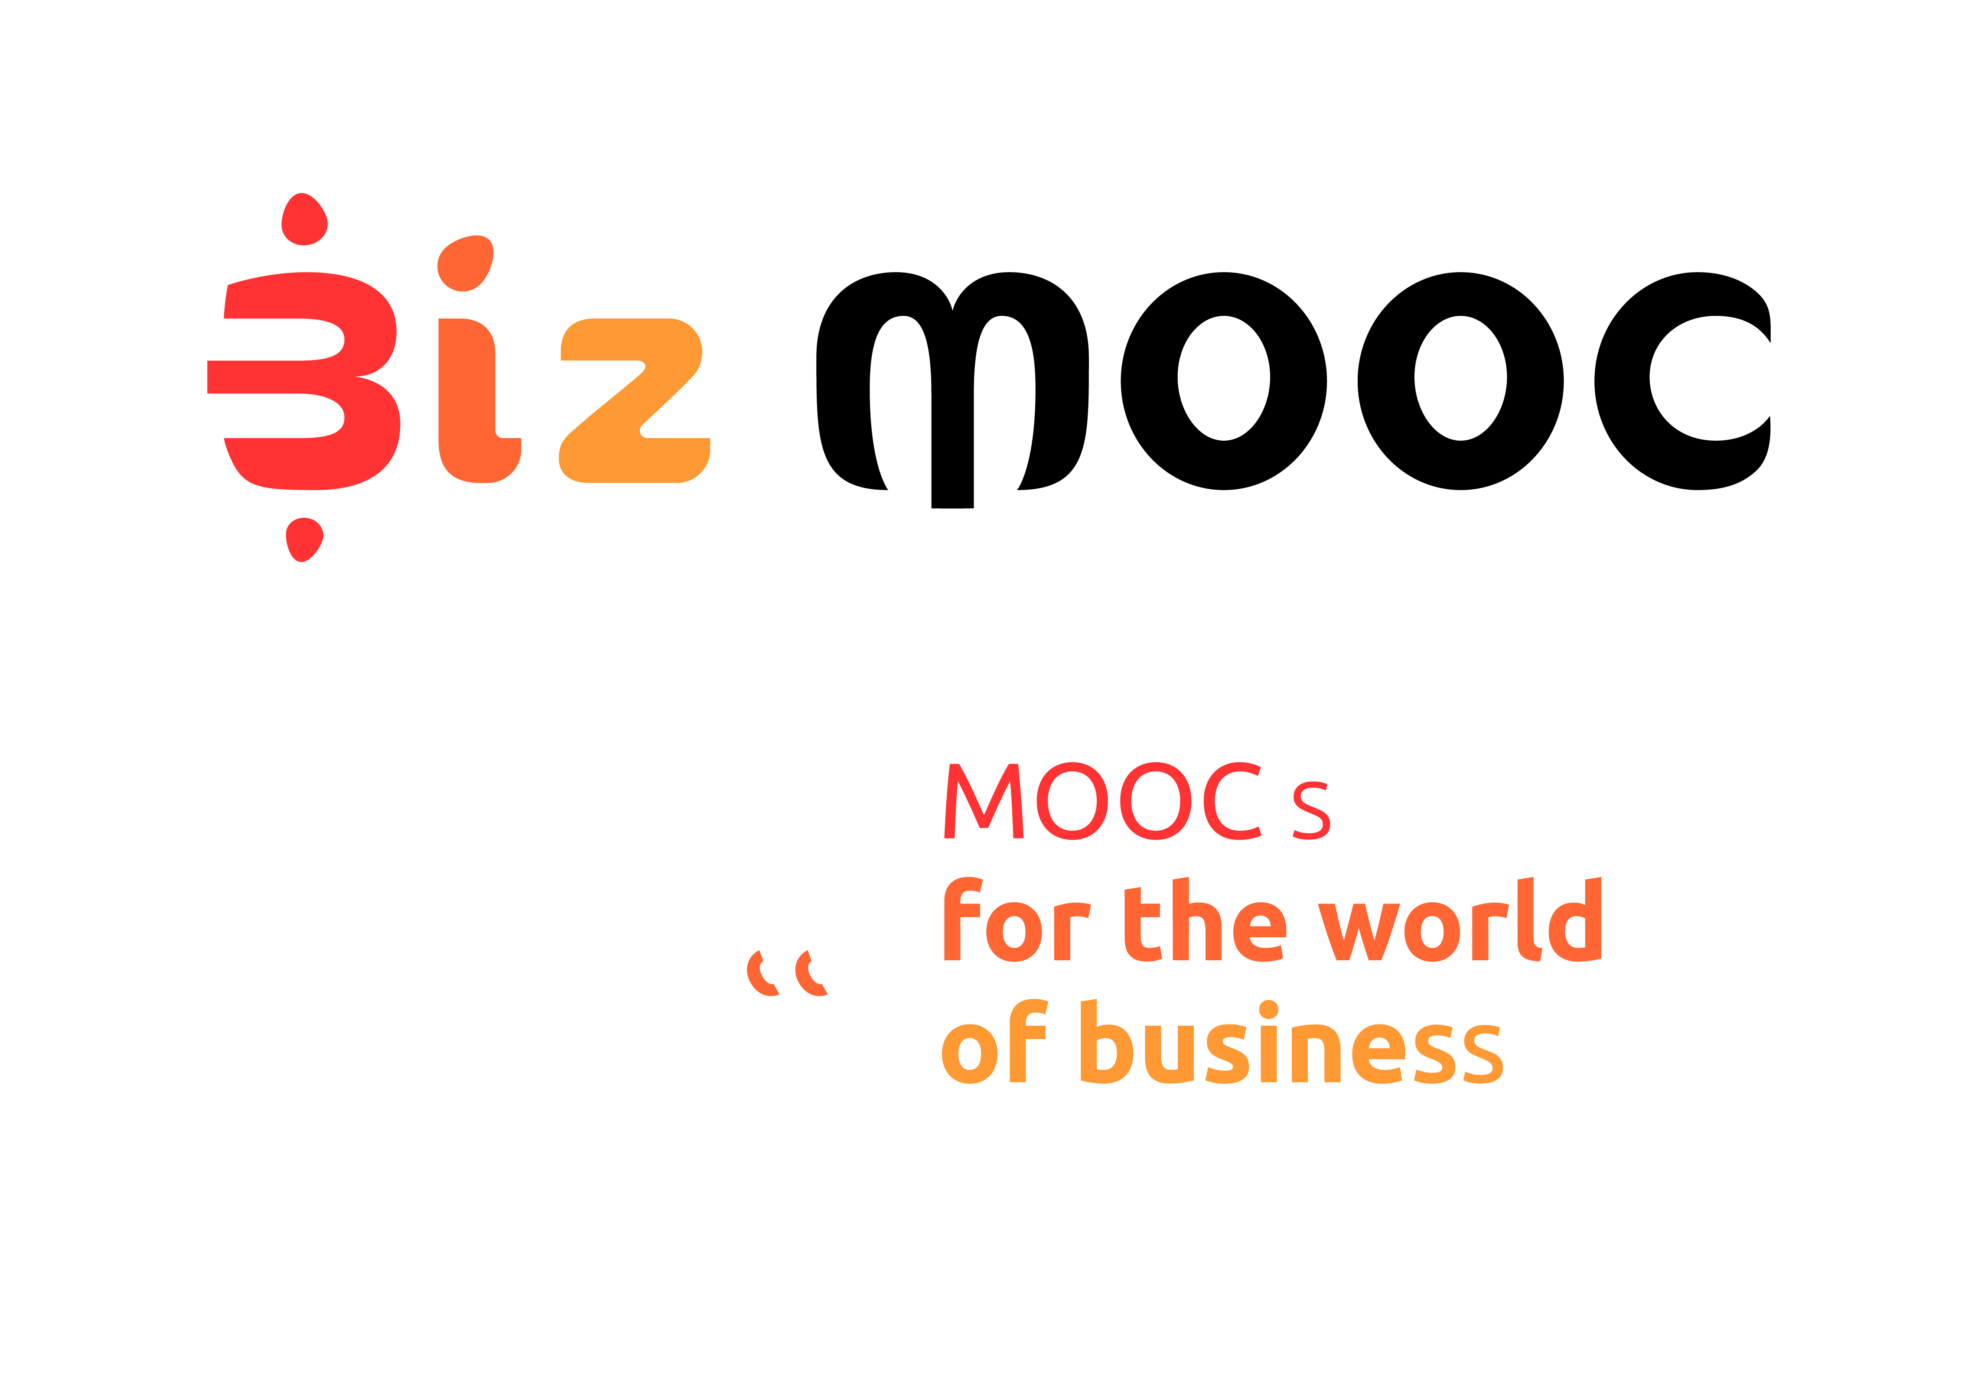
08
Fall

BizMOOC Ressources
Pre-MOOC Expert Evaluation
  - Pre-MOOC Expert Evaluation

BizMOOC Ressources
Pre-MOOC Expert Evaluation

BizMOOC - BizMOOC - Knowledge Alliance to enable a European-wide exploitation of the potential of MOOCs for the world of business
Programme: Erasmus+ | Key Action 2 | Knowledge Alliances
Reference Number: 562286-EPP-1-2015-1-AT-EPPKA2-KA
Grant agreement number: 2015-2929 / 001-001
Project Duration: 36 months, 1/1/2016 – 31/12/2018

www.mooc-book.eu
www.bizmooc.eu

In this document, we highlight open questions used to get feedback from external experts before the MOOC starts. This has a generic framework but some questions are tailored to specific aim and target group of the MOOC. We have created them for the BizMOOC project. There are general questions for all 3 Pilot MOOCs we have done and specific questions for each MOOC according to topic & specific target audience. Feel free to use, adapt, it has an open license. (CC-BY license). There are also Post-Course MOOC Expert Evaluation questions existing on mooc-book.eu.

GENERAL OPEN QUESTIONS
- Which topics of the MOOC would be the most relevant for your peers/target group (your employees/colleagues/students..)?
- What benefits do you see for your peers/target group (short-term ; long-term)?
- What could be potential barriers for your peers/target group for not enrolling or completing the course?

ADDITIONAL QUESTIONS FOR EACH MOOC TEAM (to the specific content, format, whatever)
MOOC1 Learning with MOOCs for Professional Development
- Learning with MOOCs for Professional Development invites participants to reflect on their learning and how they operate online; in your opinion, is this reflective approach helpful to your peers/target group?“
- „In your opinion, and bearing in mind your peers/target group, how appropriate is it to have participants work through the course at their own pace?“
- „Upon completion, participants will receive a Statement of Participation; how do you think this will motivate them to finish the course?“

MOOC2: How to generate innovative ideas and how to make them work
- This MOOC invites participants to reflect on creativity and generating innovative ideas; in your opinion, is this reflective approach helpful to your peers/target group?
- In your opinion, and bearing in mind your peers/target group, how appropriate is it to have participants work through the course at their own pace
- Upon completion, participants will receive a Completion Certificate; how do you think this will motivate them to finish the course?

MOOC3: Intrapreneurship
- Did you offer any trainings enhancing entrepreneurial skills or behavior to your employees so far?
- Did you ever recommend a MOOCs to your employees/peers so far?
- Upon completion, participants will receive a Completion Certificate: How do you think this will motivate them to finish the course?

