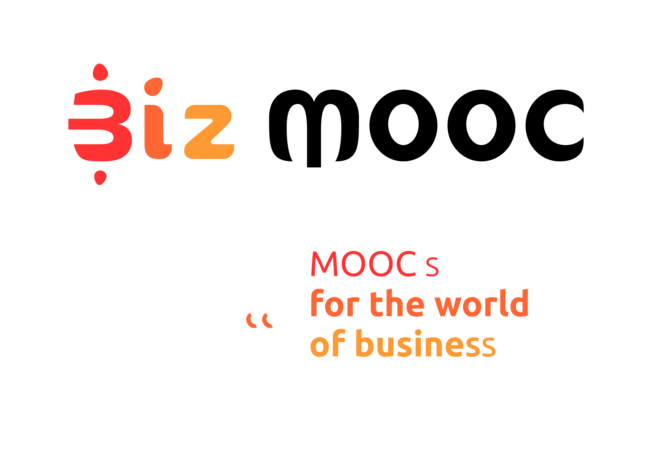
08
Fall

BizMOOC Ressources
Post-Course Survey MOOC Participants
  - Post-Course Survey MOOC Participants

BizMOOC Ressources
Post-Course Survey MOOC Participants

BizMOOC - BizMOOC - Knowledge Alliance to enable a European-wide exploitation of the potential of MOOCs for the world of business
Programme: Erasmus+ | Key Action 2 | Knowledge Alliances
Reference Number: 562286-EPP-1-2015-1-AT-EPPKA2-KA
Grant agreement number: 2015-2929 / 001-001
Project Duration: 36 months, 1/1/2016 – 31/12/2018

www.mooc-book.eu
www.bizmooc.eu

In this document, we highlight potential questions to be asked in a post-course survey to MOOC participants which is adressed at professional lifelong learners (“the world of business”). We have created them for the BizMOOC project. There are general questions for all 3 Pilot MOOCs we have done and specific questions for each MOOC according to topic & specific target audience. Feel free to use, adapt, it has an open license. (CC-BY license). MA means Multiple Answers and MC means Multiple Choice. There is also a Pre-Course Survey existing on mooc-book.eu contrasting the questions after course implementation.

GENERAL QUESTIONS
Was this the first time you took part in a free online course?
Yes
No

Were your expectations for the course fulfilled? (MC)
- 1 (not fulfilled)
- 2
- 3
- 4
- 5 (completely fulfilled)

If not, what was missing?...

Did you complete the course? (MC) (If the platform allows to send the post survey to all users)
- I’ve finished the complete course
- I thought I would have time, but I did not
- It was boring
- The contents weren’t interesting
- It required too much effort
- It required prior knowledge that I did not have
- The use of the platform was difficult for me
- I’ve finished the parts I wanted to follow
- Other
If you chose "Other" you can provide more details here: …

Did the opportunity to earn a [certificate/badge/statement of participation/achievement] encourage you to complete the course?
- Yes
- No

How would you rate the quality of the course materials? (MC)
- 1 (very poor)
- 2
- 3
- 4
- 5 (excellent)

How would you rate the quality of the course activities? (MC)
- 1 (very poor)
- 2
- 3
- 4
- 5 (excellent)

How would you rate the length of the course? (MC)
- 1 (not appropriate)
- 2
- 3
- 4
- 5 (appropriate)

How would you rate the degree of difficulty of the course? (MC)
- 1 (very easy)
- 2
- 3
- 4
- 5 (very difficult)

How would you rate the understandability of the course? (MC)
- 1 (very poor)
- 2
- 3
- 4
- 5 (excellent)

How much time did you spent on average on the course per week? (MC)
- Less than 3 hours
- 3-6 hours
- 6-9 hours
- 9-12 hours
- More than 12 hours

Would you recommend the course to others? (MC)
- Yes
- No
If no, why not?

Would you like a continuation (Part 2) of the course? (MC)
- Yes
- No

Would you participate in another course from BizMOOC? (MC)
- Yes
- No

Would you recommend courses from BizMOOC to others? (MC)
- Yes
- No

Did the opportunity to earn a [certificate/badge/statement of participation/achievement] encourage you to complete the course?

If you have any other comments, please feel free to add them here: [open text box]

Optional: Repeat demographic Qs from pre survey?

ADDITIONAL QUESTIONS FOR EACH MOOC TEAM (to the specific content, format, whatever)

MOOC1 Learning with MOOCs for Professional Development

Q. Did the Statement of Completion encourage you to complete the course?
Yes
No
Please tell us why (open box)

Q. To what extent do you think you will be able to apply in real life what you learned in this course?
5 A lot
1 Nothing at all
Please explain why/how: (open box)

Q. In what ways, if any, has taking this course changed what you do online and how you learn online? (open box)

MOOC2: How to generate innovative ideas and how to make them work

Post-Survey
- Do you consider the skills in idea generation obtained during the course have improved your creative capacities?
  - Yes
  - To some extent
  - No
  - Not sure

- Which of the course main topics do you find more interesting?
  - Ideation methods
  - Critical thinking
  - Problem solving methods
  - Learning from failure
  - Idea evaluation
  - Ownership

- Do you feel more motivated to have your own ideas and make them work?
  - Yes
  - To some extent
  - No
  - Not sure

- Do you consider that the course improves your problem solving skills?
  - Yes
  - To some extent
  - No
  - Not sure

- Do you feel more confident to share and discuss your own ideas with other people?
  - Yes
  - To some extent
  - No
  - Not sure

- After the course, do you think that you ability to learn in positive from failure experiences is improved?
  - Yes
  - To some extent
  - No
  - Not sure

MOOC3: Intrapreneurship

- To what extent will you be able to use what you learned in this course at work?
  - 0 - not at all
  - ...
  - 10 - this will help me extraordinarily
- The course provided an intrapreneurial toolbox. How useful do you consider the tools?
  - 0 - not at all
  - ...
  - 10 - this will help me extraordinarily

